

**Machine Learning I**

**Linear Regression Assignment**

**Predicting Housing Prices in Madrid**

Group Assignment 1

MBD – A1 – Group C

**Table of Contents**

1. Executive Summary 1

2. Model Specification and Results 1

*2.1.* *Specification and overall metrics* 1

*2.2.* *Model assumptions and robustness* 1

*2.3.* *Interpretation of results* 2

3. Technical approach 2

*3.1.* *Data cleaning process* 2

4. Conclusions 4

*4.2.* *Recommendations for real estate agency* 4

5. Technical Annexes 5

5.1. Annex I – Distribution of Rent in Districts per Area 5

5.2. Annex II – Distribution of Rent before and after Box-Cox Transformations and removing outliers 6

5.3. Annex III – Checking assumptions of the OLS on the dataset and the model 7

5.4. Annex IV – Distribution of log_Rent and Square Meters 9

5.5. Annex V – Detailed metrics for the model (target – ln_Rent) 9

5.6. Annex VI – Coefficients table. 10

5.7. Annex VII – Reference Area dummies, automatically chosen by the algorithm 11

5.8. Annex VIII – Actual vs. Predicted Values. 11

5.9. Annex IX – Dataiku flow representing data preparation stages and modelling stage 12

# Executive Summary

A linear regression analysis was performed in order to create a model that would predict rent prices in Madrid based on historical data from Idealista. This model could help adjust the pricing strategy of the main players on this market, the landlords, which could benefit real estate agencies who make profit via obtaining commission fees for the properties that rent out. By ensuring that rental units are appropriately priced given all of their features, the rental agency can maximize their earnings by increasing the monthly rental of underpriced units, or by decreasing the amount that landlords are asking if their units are overpriced, ensuring that the units are rented out.

The final algorithm selected for this model was an OLS and specification included all the available features except district and bedrooms, since price varies between various areas in one district – as seen in Annex I. The current model is capable of explaining 82% of the variability of the price given the information provided. Based on the predictions, the model helps to pinpoint apartments that are either under or overpriced, which provides the real estate agency with unique opportunities for fairly accurate strategies on increasing profit and optimizing their portfolio.

# Model Specification and Results

## *Specification and overall metrics*

The selected model can explain 82% of the variation in the price with the information available through Idealista. On average, the model makes a mistake by 16.95% in Price, meaning that on average the error of the prediction is 328 euro (higher or lower than actual market price). The model takes into account *Area*, *Outer* (whether the flat faces interior patio or not), *Elevator*, *Floor* (meaning which floor the apartment is on), logarithm of *square meters* and type of the house (*Cottage, Duplex and Semi-Detached* were claimed insignificant during stepwise procedure*,* thus only *Penthouse* appeared in the final model). The target variable is logarithm of the rent price since the logarithm of Rent follows normal distribution in comparison with Rent on its own, as show in Annex II*.* The modelwas optimized for R squared. The resulting equation from the linear regression analysis is the following:

$\hat{{ln_Rent}_{i}}=6.96+0.014×{Floor}_{i}+0.026×{Elevator}_{i}+ 0.028×{Outer}_{i} - 0.031×{Penthouse}_{i}+ 0.688×{ln⁡_Sq_mt}_{i}+{\hat{β}}_{j}×{Area}_{i}^{j}$,

where coefficient before the Area depends on which area we’re looking at.

One has to take in account that due to additive nature of OLS increasing variables leads to higher R square, thus, inserting more than a hundred dummies of Area may artificially raise the R squared value. In this case, the most accurate accuracy metric would be MSE or MAE. After calculating MSE for Rent (not ln_Rent) we found that this indicator is 16.95%, as already mentioned before, which is the best accuracy we can get with given dataset.

## *Model assumptions and robustness*

The algorithm used in this prediction was an OLS algorithm. For this algorithm to be valid, several assumptions need to be validated, those being:

* Homoscedasticity in the residuals;
* Lack of correlation between the independent variables (predictors);
* Lack of correlation between the residuals;
* Normal distribution of the residuals

All the assumptions were checked prior (in the case of multicollinearity) and after modelling. None of these assumptions have been broken, thereby showcasing the validity of algorithm choice. Annex IIIprovides graphs that represent those distributions.

Furthermore, in order to ensure robustness of the model another validation step was taken through the use of k-folds cross validation with 5 folds being selected due to rather small size of this dataset.

## *Interpretation of results*

All the coefficient signs for this model appear to be logical which makes this model applicable for the business. The most important factors affecting price are the area in which the apartment is located in and the square meters of the house. Other factors change the rent by less than 5%. Apartments situated in Recoletos and Jerónimos increase the rent by 76% and 73% respectively in comparison with the reference areas automatically chosen by the algorithm (Annex VII). The next most expensive areas according to the model are Almagro, with an increased rent of 64%, Castellana and El Viso, with commanding an increase of 63% and 62% respectively.

Renting in 24 out of 132 areas in Madrid is actually cheaper than in reference areas, all other things equal. A full list of areas can be found in Annex VI*,* for example living in Los Ángeles is 26.5% cheaper than living in the reference areas; living in Arcos reduces rent by 22%.

Penthouses are 3% more expensive than any of the other types of houses, having an exterior view as opposed to be locked into the interior patio increases rent by 2.8%. If an apartment is situated one floor higher, the price will increase by 1.4%. The presence of an elevator increases the price by 2.6%. A 1% increase in the area of the house increases the rental price by 0.69%.

Duplex, semi-detached and cottage type houses do not have any significant impact on the rent in this model which may seem counterintuitive. That may be explained by the fact that those types of dwellings represent not more than 3% of the data. Thus, they do not make a significant difference in a model trained with this particular dataset. Penthouses represent 7.6% of the data and are the most expensive types of rentals, which may be why they are the only type of unit present in the final model as a significant output.

There were 902 overestimated, 1029 underestimated and only 6 more or less correctly priced apartments in the historical data. That indicates that rent real estate market is not in equilibrium, which is a very frequent case in real life.

# Technical approach

## *Data cleaning process*

The approach to this study first began with understanding the available information that has been provided. The dataset consists of 2000 observations with 13 explanatory variables which focus on the various attributes of a property. All these variables were examined to gain a better perspective.

1. The objective of this study is to determine the rent of a property using the given characteristics. The distribution of the rent is examined and shown in Annex II. The outliers were then removed, as not dropping them will affect the model significantly. Note that the range of Rent decreased significantly after dropping just the top 2 percentile of the data. The distribution of the rent is heavily skewed towards the right, hence a log transformation is applied to normalize the data, as shown in Annex II.
2. The variable District was examined, it has no missing values, and a comparison of the rent per district is presented in Annex I. It can be noted that rent varies greatly within the same district. Hence using this variable in the model to estimate the price may lead to ignoring relevant information and, therefore, biased results.
3. The variable Area is a sub-part of the District, which tells about in which area of the District the house is located. There are 4 missing values for this variable and all of them belong to the district of Tetuan. Those missing values are imputed with the mode of Area where the district is Tetuan. Apart from the missing values, this variable has other quality issues such as having the same areas but with different spellings, all of these simple issues are corrected.
4. The variable Bedrooms indicates the number of bedrooms present in the house. There are 89 missing values, which are predicted by using a linear model based on other relevant variables. However, this variable was dropped in the final model as it was found to be highly correlated with Sq.Mt. (Square Meters) which was used in the final predictions.
5. The variable Sq. Mt. corresponds to the area of the house in square meters. There are no missing values, but there are outliers which are remove by dropping the top 1 percentile of the data. The relationship between Sq. Mt. and the logarithm of Rent was found to be non-linear, hence a log transformation was applied to linearize the relationship, as demonstrated in Annex IV.
6. The variable Floor indicates on which floor the rental unit is located on. There are missing values most of which are imputed on the basis of an educated guess based on other variables, such as if the house was a cottage, then the floor was 0, under the assumption of all cottages being small houses located on the ground floor. A few invalid values such as 0.5 were recoded as 1, assuming that the house is on the floor, which is higher than the ground floor, and -0.5 was recoded as -1, assuming that the house is on the floor which is less than the ground floor. There are 2 records which were dropped as they had dates for this variable. After that there remained several missing values.
7. The variable Outer indicates if the rental unit faces the exterior of the building or not. There are missing values most of which are imputed on the basis of an educated guess based on other variables such as if the house is a cottage then for that house Outer =1, again under the assumption that all cottages are independent small houses. Several missing values still remained after the process.
8. The variable Elevator indicates if the house can be accessed through an elevator or not. There are missing values most of which are imputed on the basis of an educated guess based on other variables. However, some of the observations still have missing values.
9. The variables Penthouse, Cottage, Duplex & Semi-detached indicate the type of house. There are no missing values in these variables.

A cluster analysis was performed using the variables which did not have any missing values. The remaining missing values in Elevator, Outer and Floor were imputed by mode of the obtained clusters. The data now has no missing values and can be used for further analysis. Following this initial study, a correlation analysis was performed to determine which of the variables are highly correlated in order to avoid multicollinearity. The results of this analysis are available in Annex III.

# Conclusions

* 1. *General implications of the model.*

Whilst the main goal of people trying to rent is to find an apartment which satisfies all of their required features and minimizes price at the same time, the main goal of real estate agencies is to ensure the highest amount revenue. This revenue is derived from the commission from both the client who’s trying to rent and the owner of the apartment who’s using real estate agency’s services for advertisement and other purposes. If the market price is lower than what is predicted, it means that the flat price is underestimated and in the long run the price will increase since the demand will rise. In the short run for a client that is an opportunity to rent it cheaper than he could’ve rented. However, for the real estate agency it means lost revenue from the commission on the rent which could’ve been higher had the price been set correctly.

If the market price is higher than prediction, it means that the apartment is, on the contrary, overestimated and in the long run the price will decrease. From the client perspective he should wait for the prices to drop whilst for the real estate agency this is considered to be a good asset in the portfolio since currently it’s bringing in more revenue than it actually should. However, this situation is also a signal that in several months the price for this apartment will drop and if no actions are taken our cash inflow will reduce as well.

There are slightly more overestimated apartments in the dataset than underestimated (53,4% vs. 46,6%). This means that if the current dataset represents real estate agency’s current profile it’s making more money now than it will later.

## *Recommendations for real estate agency*

In order to maximize profit, the real estate agency can take steps in two different directions.

First one implies interaction with the landlords. The agency could talk to the landlords of the apartments that are currently underpriced and encourage them to increase the rent since the demand for their flats is higher than they believe. This will bring additional commission without losing potential tenants since they are willing to pay more. The top 5 underpriced districts are Centro, Salamanca, Chamartín, Chamberí and Tetuán. More over the areas within districts that are underpriced are Recoletos, Chueca-Justicia, Castellana, Argüelles and Cuatro Caminos. Thus, landlords in those areas should be addressed first, following other areas within top underestimated districts and finally other underpriced flats.

Penthouses are underpriced 1.14 times more often than they are overpriced, while cottages are twice more often overpriced than underpriced. Semi-detached houses are 1.5 times more often overpriced than underpriced. Duplexes are 1.3 times more likely to be overpriced than underpriced. Thus, the real estate agency should try to limit the number landlords who are trying to rent out semi-detached houses or cottages from listing with them.

Another approach would be focusing on the tenants and providing them with insights regarding which of the apartments on the market are actually underpriced versus the market rates. Since tenants are always seeking the cheapest opportunity to rent an apartment that they like, they could be provided with personalized suggestions based on their preferences and chosen features, with feedback being provided on whether the rent asked is fair considering the market price, possibly for a small fee. Though it must be noted that the first approach seems to be more feasible since landlords are the ones that select the prices, thereby helping them optimize the amount they are asking could ensure that both them and the tenants are satisfied with this arrangement.

# Technical Annexes

## **Annex I – Distribution of Rent in Districts per Area**

The rent varies a lot in the district itself which was the main reason as to why we chose Area to train the model instead of District.

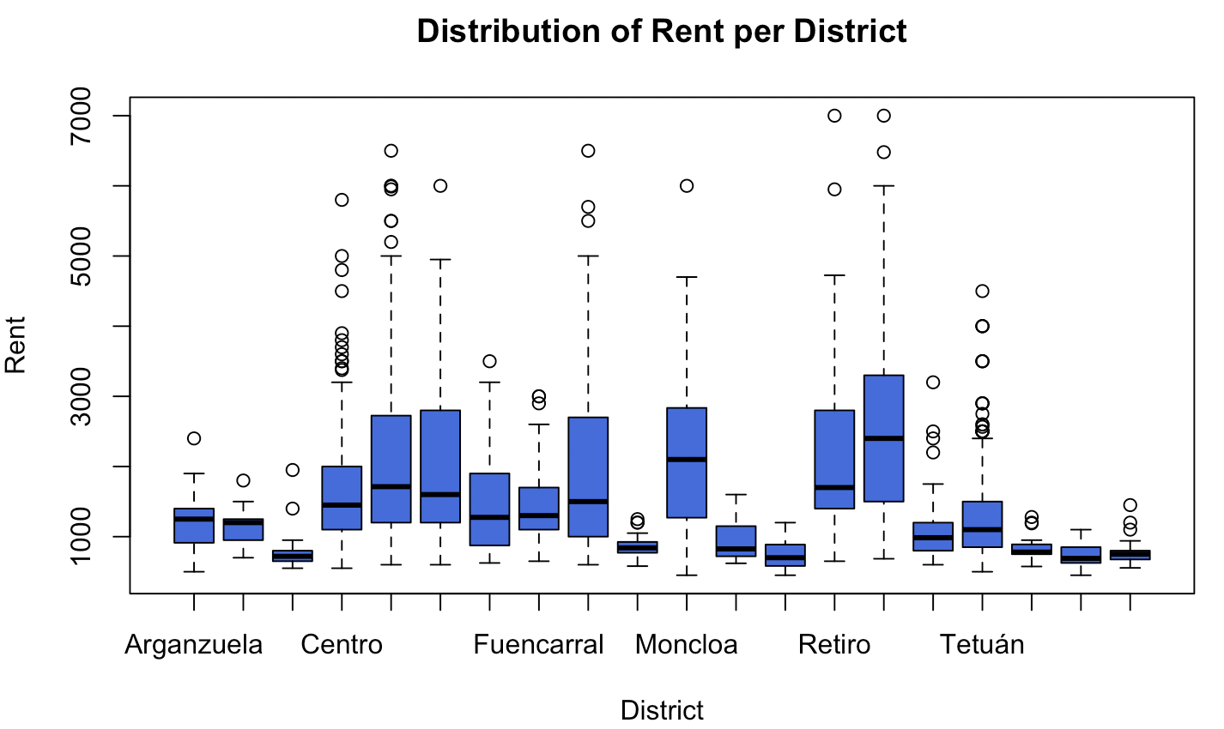

## **Annex II – Distribution of Rent before and after Box-Cox Transformations and removing outliers**

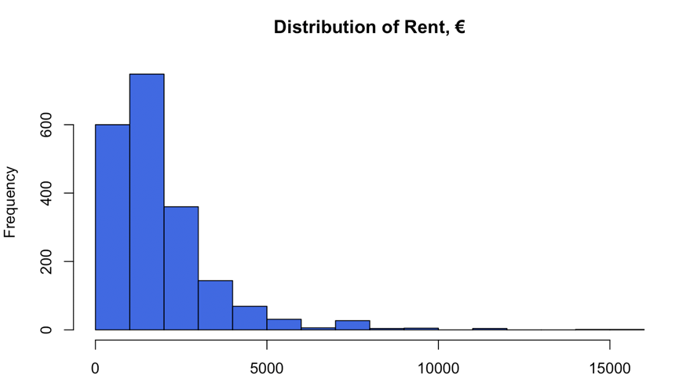

We decide to remove the outliers by dropping the top 2 percentile of the data.

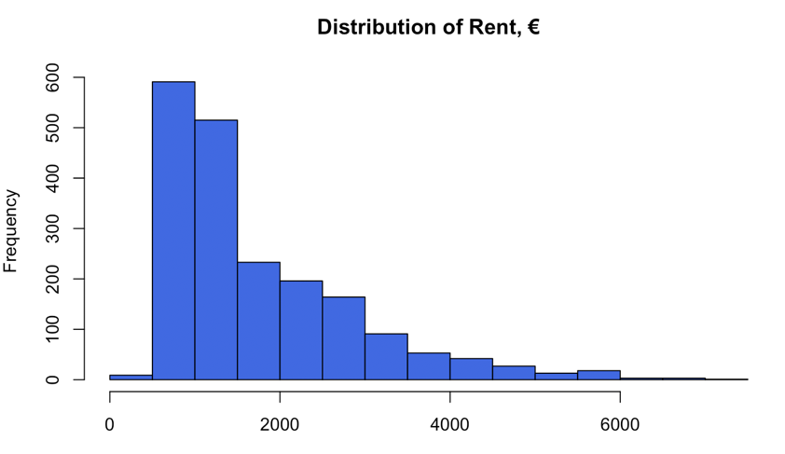

The distribution seems to be fairly normal.

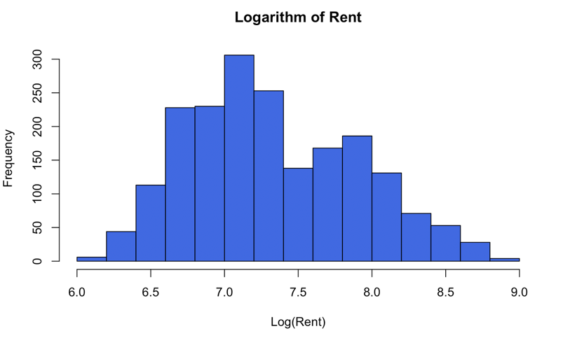

## **Annex III – Checking assumptions of the OLS on the dataset and the model**

There seems to be no autocorrelation or heteroscedasticity in the residuals.







Residuals follow the normal distribution.



There’s no correlation between numerical independent variables in the dataset, except for bedroom and sq.mt. which is logical. Therefore, bedroom variable was dropped to process with the modelling.



## **Annex IV – Distribution of log_Rent and Square Meters**

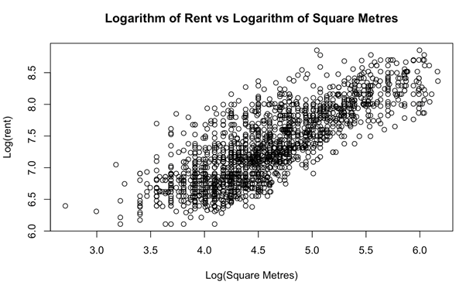As demonstrated, the relation between sq_mt and ln_Rent seems non-liner, thus, a Box Cox transformation was applied to ensure linear relationship between the target variable and its predictor:

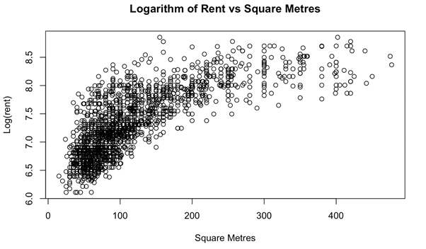

## **Annex V – Detailed metrics for the model (target – ln_Rent)**

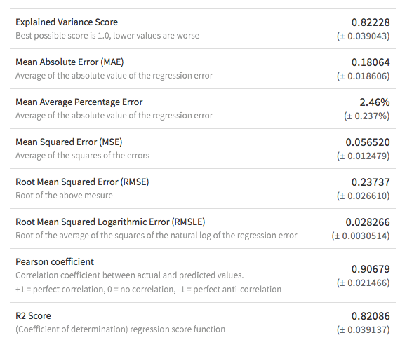

## **Annex VI – Coefficients table.**

|  |  |
| --- | --- |
| **feature_description** | **coefficient** |
| Area is Recoletos | 0,760 |
| Area is Jerónimos | 0,727 |
| Area is Almagro | 0,640 |
| Area is Castellana | 0,627 |
| Area is El Viso | 0,616 |
| Area is Niño JesÁºs | 0,587 |
| Area is Chueca-Justicia | 0,576 |
| Area is Goya | 0,563 |
| Area is Palacio | 0,534 |
| Area is Sol | 0,531 |
| Area is Malasaña-Universidad | 0,520 |
| Area is Huertas-Cortes | 0,517 |
| Area is Lista | 0,513 |
| Area is Vallehermoso | 0,511 |
| Area is Argüelles | 0,499 |
| Area is Trafalgar | 0,481 |
| Area is Nueva España | 0,474 |
| Area is Ibiza | 0,445 |
| Area is Valdemarín | 0,441 |
| Area is Atalaya | 0,427 |
| Area is Bernabéu-Hispanoamérica | 0,424 |
| Area is Conde Orgaz-Piovera | 0,423 |
| Area is Lavapiés-Embajadores | 0,402 |
| Area is Ciudad Jardín | 0,398 |
| log_Sq_Mt | 0,689 |
| Area is Nuevos Ministerios-Ríos Rosas | 0,368 |
| Area is Cuatro Caminos | 0,362 |
| Area is Arapiles | 0,361 |
| Area is San Pascual | 0,350 |
| Area is Fuente del Berro | 0,345 |
| Area is Gaztambide | 0,342 |
| Area is Aravaca | 0,340 |
| Area is Pacífico | 0,312 |
| Area is Acacias | 0,305 |
| Area is Estrella | 0,299 |
| Area is Guindalera | 0,282 |
| Area is Cuzco-Castillejos | 0,273 |
| Area is San Juan Bautista | 0,272 |
| Area is Palomas | 0,271 |
| Area is Los Ángeles | -0,256 |
| Area is Palos de Moguer | 0,255 |
| Area is San Andrés | -0,254 |
| Area is Mirasierra | 0,235 |
| Area is Arcos | -0,219 |
| Area is Imperial | 0,213 |
| Area is Legazpi | 0,211 |
| Area is Prosperidad | 0,211 |
| Area is Valdezarza | 0,203 |
| Area is Ventilla-Almenara | 0,203 |
| Area is Montecarmelo | 0,200 |
| Area is Costillares | 0,197 |
| Area is Castilla | 0,197 |
| Area is Colina | 0,196 |
| Area is Butarque | -0,190 |
| Area is Arroyo del Fresno | 0,188 |
| Area is Sanchinarro | 0,188 |
| Area is Abrantes | -0,179 |
| Area is Valdebebas - Valdefuentes | 0,174 |
| Area is Palomeras sureste | -0,173 |
| Area is ZofÁ­o | -0,171 |
| Area is Quintana | 0,166 |
| Area is Valdeacederas | 0,162 |
| Area is Aluche | -0,159 |
| Area is Ciudad Universitaria | 0,158 |
| Area is Vista Alegre | -0,154 |
| Area is Casco Histórico de Vallecas | -0,152 |
| Area is Bellas Vistas | 0,148 |
| Area is Pau de Carabanchel | -0,142 |
| Area is Las Tablas | 0,134 |
| Area is Concepción | 0,133 |
| Area is La Paz | 0,127 |
| Area is Pinar del Rey | 0,124 |
| Area is Puerta Bonita | -0,118 |
| Area is Fuentelarreina | 0,118 |
| Area is Salvador | 0,115 |
| Area is Delicias | 0,113 |
| Area is Puerta del Ángel | 0,112 |
| Area is Ensanche de Vallecas - La Gavia | -0,109 |
| Area is Tres Olivos - Valverde | -0,108 |
| Area is Canillas | 0,095 |
| Area is Berruguete | 0,094 |
| Area is Media Legua | -0,089 |
| Area is Peñagrande | 0,087 |
| Area is Numancia | -0,080 |
| Area is Valdebernardo - Valderribas | -0,072 |
| Area is Rosas | 0,071 |
| Area is San FermÁ­n | -0,070 |
| Area is Palomeras Bajas | 0,070 |
| Area is Ambroz | -0,051 |
| Floor | 0,014 |
| Penthouse is 0 | -0,031 |
| Area is Campamento | -0,029 |
| Outer is 1 | 0,028 |
| Area is San Diego | 0,027 |
| Area is Ventas | 0,027 |
| Elevator is 1 | 0,026 |
| Area is San Isidro | -0,025 |
| Area is Apóstol Santiago | -0,025 |
| Area is Lucero | -0,019 |
| Area is Barajas | 0,018 |
| Area is Pueblo Nuevo | 0,017 |
| Area is Opañel | 0,014 |
| Area is Almendrales | 0,010 |
| Area is Rejas | 0,010 |
| Area is Simancas | 0,000 |
| Area is Pilar | 0,000 |
| Intercept | 6,958 |

## **Annex VII – Reference Area dummies, automatically chosen by the algorithm**

|  |
| --- |
| 12 de Octubre-Orcasur |
| Adelfas |
| Buena Vista |
| Canillejas |
| Chopera |
| Comillas |
| El Plantío |
| Entrevías |
| Escalinata |
| Esperanza |
| Fontarrón |
| Gasómetro |
| Hellá­n |
| Horcajo |
| Los Cármenes |
| Los Rosales |
| Manoteras |
| Marroquina |
| Moscardó |
| Oriana |
| Pavones |
| Peña |
| Plaza de España |
| Portazgo |
| Pradolongo |
| San Bernardo |
| Sodio |
| Toledo |
| Vinateros |

## **Annex VIII – Actual vs. Predicted Values.**

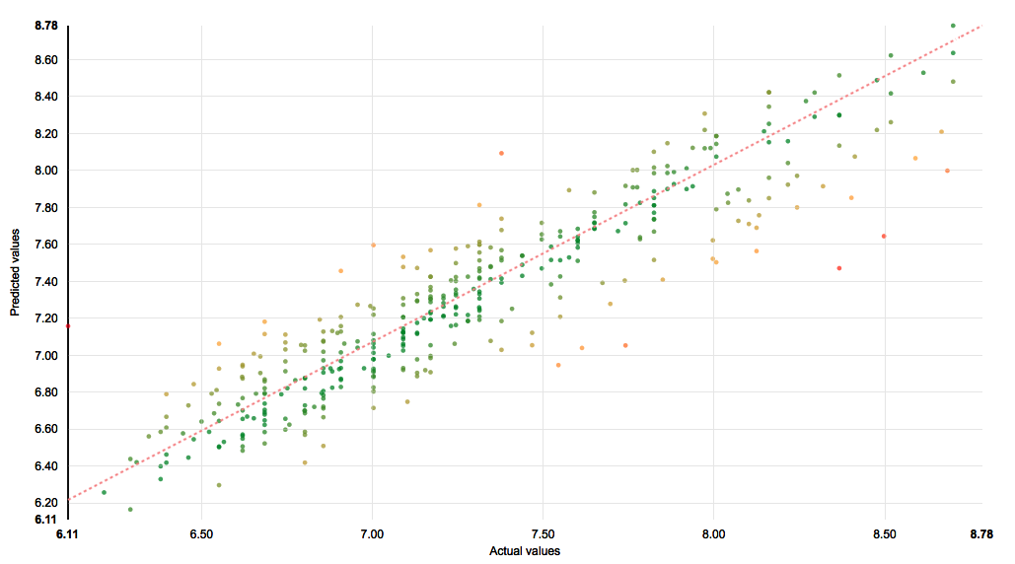

## **Annex IX – Dataiku flow representing data preparation stages and modelling stage**

